Algebra 1 Name ___________________________

Chapter 1 Closure Date ____________________________

1. Use the Order of Operations to simplify the following expressions.

EQ 1.0 Precision

1. $5-2 ∙ 3^{2}$ b. ${(-2)}^{2}$

c. $18 ÷3 ∙6$ d. ${-2}^{2}$

e. $(5-3)(5+3)$ f. $24 ∙ \frac{1}{4} ÷ -2$

g. Why are your answers for parts (b) and (d) different?

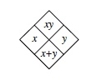

2. Complete the diamond problems using the pattern to the right.

EQ 1.0 Precision

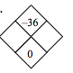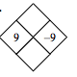



a. b.

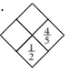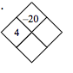

c. d.

3. Graph and fully describe the function $y=2\sqrt{x-1}+3$

EQs:

1.0 Precision

1.1  I can determine if a relation is a function

1.2  I can evaluate functions for given values of x by creating a graph or table

1.3  I can evaluate functions for given values of x using function notation

1.4  I can identify the x and y intercepts in a table or graph for functions

1.5  I can describe the direction of the function (increasing/decreasing)

1.6  I can describe maximum, minimums and symmetries for functions

1.9  I can graph square root functions 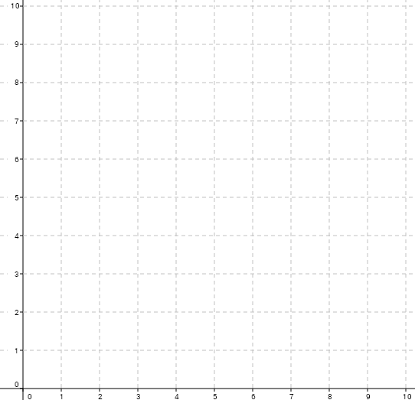

4. Solve each equation. Make sure you check your solution.

EQs:

1.0 Precision

1.7 I can solve one variable equations without parentheses

a. b.

c. d.

5. Find for each function below.

EQs:

1.0 Precision

1.3 I can evaluate functions for given values of x using function notation

1.8 I can perform operations with cube root, square root, and absolute value expressions

a. b.

c.

6. Evaluate each expression.

EQs:

1.0 Precision

1.8 I can perform operations with cube root, square root, and absolute value expressions

a. $2÷|3-4|$ b. 11|-6|+15 c.

d. e. f.

7. Use the function machine shown at right to answer the

following questions.

EQs:

1.0 Precision

* 1. I can evaluate functions for given values of x using function notation

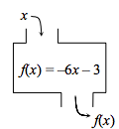Precision

1. If the input is -8, what is the output?
2. If the output was 21, what was the input?