Algebra 1 Name: _________________ Per:____

1.2.1 through 1.2.5 Homework Packet Due Date:_______________________

**Lesson 1.2.1 Day 1**

**1-33.** Complete the following Diamond Problems and use the pattern you discovered earlier to complete each of them.  Some of these may be challenging!

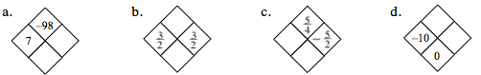

**1-34.** Evaluate the following absolute value expressions.

1.  b. 



c. d. 

**1-35.** The solution to the equation  is called the **cube root** of 64.  The idea is similar to the idea of a square root, except that the value must be cubed (multiplied by itself three times) to become 64.  One way to write the cube root of 64 is using the notation  .  Use this information to evaluate each of the following expressions.

* 1.  b.  c.  d. 

**1-36.** Solve the following linear equations.

a. 8*x* + 1 = −*x* – 1 b. −4*x −*3  = 3*x* − 4 − 7*x*

c. 4 − 5*x* = 1 + 6*x* d. 7 − *x  +*3 = 9*x +*10

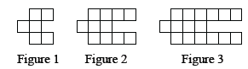**1-37.** Examine the tile pattern shown at right.

a. Draw Figure 0 and Figure 4.

* 1. How many tiles will Figure 10 have? How do you know?

**Lesson 1.2.1 Day 2**

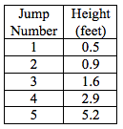**1-38.** Chari performed a series of jumps on a trampoline.  Her coach

measured the height of each jump.  The coach’s data was recorded in

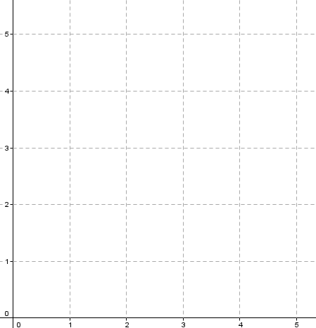the table at right.

1. Make a graph of the data.

b. Fully describe the graph.

* 1. If this pattern continues, what are a reasonable maximum and minimum for the graph?
  2. Which family of functions could model this data?  Review the Lesson 1.1.2 Math Note if you need help.

**1-39.** Use the idea of cube root from problem 1-35 to evaluate the following expressions.

1.  b.  c.  d. 

**1-40.** Solve the equations below for *x* and check your solutions.

1. −6 + 10*x* =*x +* 12 b. 10 + 5*x* = 2*x* – 11

c. −9*x* = −3*x +*18 d. 2*x*− 9*= −*7*x*

**1-41.** Find y in each equation if  *x* = 16.

1.  b.  c. 

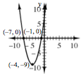**1-42.** Use your graph investigation questions from problem 1-32 to **fully describe** the graph of the quadratic equation , shown at right.

**Lesson 1.2.2**

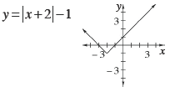**1-47.**  Use your list of graph investigation questions to **fully describe** the graph shown at right.

**1-48.** Calculate the value of each expression below.

1.    b. 

c.  d. 



**1-49.**Throughout this book, key problems have been selected as “checkpoints.”

Each checkpoint problem is marked with an icon like the one at right.  These

checkpoint problems are provided so that you can check to be sure you are building skills at the expected level.  When you have trouble with checkpoint problems, refer to the review materials and practice problems that are available in the “Checkpoint Materials” section at the back of your book.

This problem is a checkpoint for solving linear equations without parentheses.  It will be referred to as Checkpoint 1. .  From this point on, you will be expected to do problems like these correctly and with confidence. Solve each equation. 

* 1. 3*x* + 7 = −*x* – 1 b. 1 − 2*x* + 5 = 4*x* – 3

c. 4*x* − 2 + *x* = −2 + 2*x* d. 3*x* − 4 + 1 = −2*x* − 5 + 5*x*

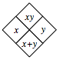

**1-51.** Complete each of the Diamond Problems below.  The pattern used in the Diamond Problems is shown at right.

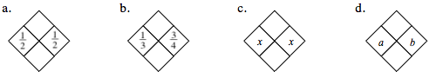

**Lesson 1.2.3**

**1-57.** If , then   Find:

a. **  b. ** c. **

**1-58.** Evaluate each expression.

* 1.  b.  c.  d. 

**1-59.** Graph and **fully describe** the function .

|  |  |  |  |  |  |  |  |  |  |  |
| --- | --- | --- | --- | --- | --- | --- | --- | --- | --- | --- |
| x | -1 | 0 | 1 | 2 | 3 | 4 | 5 | 6 | 7 | 8 |
| y |  |  |  |  |  |  |  |  |  |  |

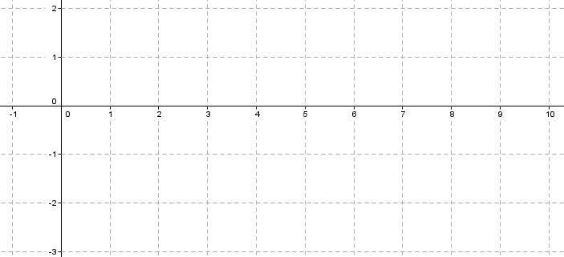

**1-60.**  There are three points on a graph. Point A (–3, –2), Point B(2, 1), and Point C (5, 3). Find the following:

a. Slope between points A and B b. Slope between points B and C

c. Slope between points A and C d. Are any of the points on the same line? Explain.

**1-61.** Find the following absolute values.

a.  b.  c.  d. 

**Lesson 1.2.4**

**1-66.** If find:

a. g(8) b. g(32) c. g(80). 

**1-67.** Solve each equation below. Check each solution. 

* 1. 6 − *x  −*3= 10 b. 100*x* + 300= 200

c.  d. 36 − 2*x* = −*x* + 2

**1-68.** Find *f*(−4) for each function below.

a.  b. 

c.  d. 

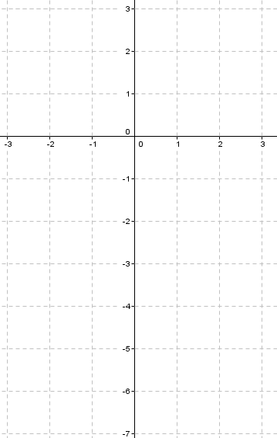**1-69.** Graph and **fully describe** the function

.

|  |  |  |  |  |  |  |  |
| --- | --- | --- | --- | --- | --- | --- | --- |
| x | -3 | -2 | -1 | 0 | 1 | 2 | 3 |
| y |  |  |  |  |  |  |  |

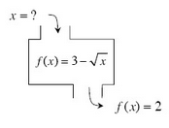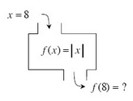**1-70.** Find the corresponding inputs or outputs for the following functions.  If there is no solution, explain why not.  Be careful: In some cases, there may be no solution or more than one possible solution.

a. b.

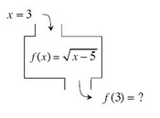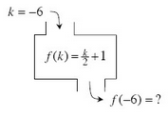

c. d.

**Lesson 1.2.5**

**1-78.** Which of the relationships below are functions?  If a relationship is not a function, give a reason to support your conclusion.

|  |  |
| --- | --- |
| x | y |
| -3 | 19 |
| 5 | 19 |
| 19 | 0 |
| 0 | -3 |

* 1. 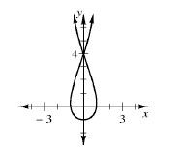 b.

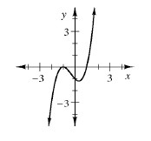

|  |  |  |  |  |  |
| --- | --- | --- | --- | --- | --- |
| x | 7 | -2 | 0 | 7 | 4 |
| y | 10 | 0 | 10 | 3 | 0 |

c. d.

**1-79.** Find the *x*- and *y*-intercepts for the graphs of the relationships in problem 1-78.

a. x-intercepts: b. x-intercepts:

y-intercepts: y-intercepts:

* 1. x-intercepts: d. x-intercepts:

y-intercepts: y-intercepts:

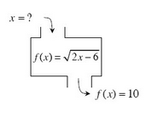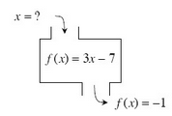**1-80.**Find the inputs for the following functions with the given outputs.  If there is no possible input for the given output, explain why not. 

a. b.

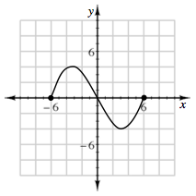

**1-81.** Use the relationship graphed at right to answer the

questions below.

a. Is the relation a function?

b. What is the domain?

c. What is the range?

**1-82.** What value(s) of *x* will make each equation true?

a.  b.  c. 