Algebra 1 Name: _________________ Per: ___

1.1.1 to 1.1.3 Homework Packet Due Date: ______________________

**Lesson 1.1.1**

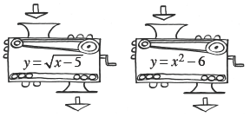**1-4.** Angelica is working with function machines.  She has the two machines shown at right.  She wants to put them in order so that the output of the first machine becomes the input of the second.  She wants to use a beginning input of 6.

* 1. In what order must she put the machines to get a final output of 5?
  2. Is it possible for her to find an input that will get a final output of –5?  If so, show how she could do that.  If not, explain why not.

**1-5.** Evaluate each absolute value expression.  Review the Math Notes box in the lesson for the definition of absolute value.

a. http://textbooks.cpm.org/images/cca/chap01/cca_ch1_less_1.1.1_1-5a.gif b. *http://textbooks.cpm.org/images/cca/chap01/cca_ch1_less_1.1.1_1-5b.gif*

c. http://textbooks.cpm.org/images/cca/chap01/cca_ch1_less_1.1.1_1-5c.gif d. http://textbooks.cpm.org/images/cca/chap01/cca_ch1_less_1.1.1_1-5d.gif

**1-6.** Examine the tile pattern below.  Next to the pattern, sketch Figures 4 and 5.

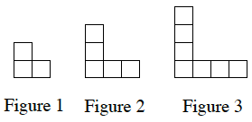

1. How does the pattern grow? Explain how you know.
2. How many tiles will there be in Figure 0 (the figure before Figure 1)?  Explain how you know.

**1-7.** Simplify each expression.

|  |  |  |  |
| --- | --- | --- | --- |
|  | a.   − 42 + (−17) | b.   8 − (−9) | c.   8 (−9) |
|  | d.   − 42 ÷ (− 7) | e.   −2 (−3) (−4) | f.   −18 − 7 |
|  | g.   (−5)2 | h.   −52 | i. http://textbooks.cpm.org/images/cca/chap01/cca_ch1_less_1.1.1_1-7i.gif |

**1-8.** For each equation below, find *y* if *x* = 2.

a. http://textbooks.cpm.org/images/cca/chap01/cca_ch1_less_1.1.1_1-8a.gif b. http://textbooks.cpm.org/images/cca/chap01/cca_ch1_less_1.1.1_1-8b.gif c. http://textbooks.cpm.org/images/cca/chap01/cca_ch1_less_1.1.1_1-8c.gif

**Lesson 1.1.2 Day 1**

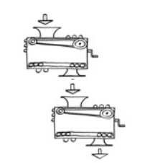**\*1-13.** What is the output from the second function machine. Show how you got your answer.

x=2

y=2x+5

y=-4x+3

**1-14.**      Evaluate each expression if *r* = −3, *s* = 4 , and *t* = 7.

a. http://textbooks.cpm.org/images/cca/chap01/cca_ch1_less_1.1.2_1-14a.gif b. 

c. 2*s* 2+ *r* – *t* d. 3(*s* − *t*)2

**1-15.** Finding and using a pattern is an important problem-solving skill you will use in algebra.  The patterns in Diamond Problems will be used later in the course to solve other types of algebraic problems.

Look for a pattern in the first three diamonds below.  For the fourth diamond, explain how you could find the missing numbers (?) if you know the two numbers (#).  
     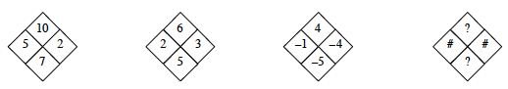

Use the pattern you discovered to complete each Diamond Problem.

     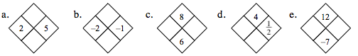

**1-16.**What value(s) of  *x*  will make each equation below true?

a. *x* + 5 = 5 b. 2*x* − 6 = 3*x*+ 1 − *x*– 7

c. 3*x* + 1= 43 d. 4*x*− 1 = 4*x* + 7

**\*1-17.** Evaluate the following:

a.  b.  c.  d. 

**Lesson 1.1.2 Day 2**

**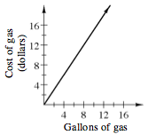****1-18.** In December of 2003, the average price for a gallon of regular gas in the United States was $1.50.

* 1. At that time, what did it cost to buy 12 gallons of gas?
  2. Gerald paid $12.60 for a tank of gas.  How many gallons did he buy?

* 1. At right is a graph of this situation.  Predict how the line would change to represent the average cost of gas in December of 2005, when gas cost $2.20 per gallon on average.

**1-19.** Solve each linear equation.  Check your solutions.

a. −2*x* − 3 = 3                        b. 7 +2*x*=4*x* – 3 c. 6*x*− 10 = −8 + 3*x*

**1-20.**  Evaluate the expressions below for the given values.

a. −2*x* 2− 3*x +*1for*x =*− 3 b. 8*−*(3*x −*2)2 for*x* = − 2

c. http://textbooks.cpm.org/images/cca/chap01/cca_ch1_less_1.1.2_1-20c.gif for*k =*−3 d. http://textbooks.cpm.org/images/cca/chap01/cca_ch1_less_1.1.2_1-20d.gif for*m =*1and*n =*2

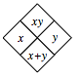**1-21.**  Complete each of the Diamond Problems below.   The pattern used in the Diamond Problems is shown at right.

       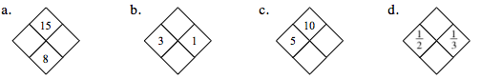

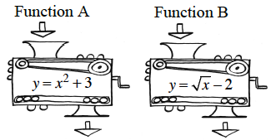**1-22.** Function Machines

a. If an input of –9 is put into each of the machines at right, what is each output?

b. Eric wants to get an ouput of 0.  Can he do this with each machine? If so, how?  If not, why not?



**Lesson 1.1.3**

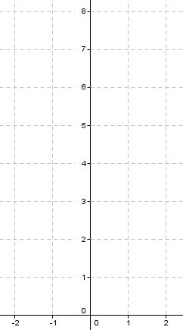**1-25.** Freda Function has another quadratic function for you to investigate!  Graph the equation *y* = *x* 2 + 3 and then answer the following questions:

|  |  |
| --- | --- |
| x | y |
| -2 |  |
| -1 |  |
| 0 |  |
| 1 |  |
| 2 |  |

a. How would you describe the shape of your parabola?

b. Does your parabola have any **lines of symmetry**?

c. Are there any special points on your parabola?

d. What are the ***x-* and *y*-intercepts**?

e. Is there a highest (maximum) or lowest (minimum) point on the graph of your parabola?  This is also called the **vertex**.

**1-26.** Complete each of the Diamond Problems. Some of these may be challenging! The pattern of the Diamond Problem is shown at the right.

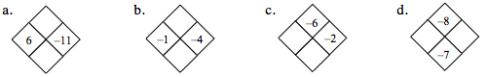

**1-27.** Draw any lines of symmetry for the shape below.

http://textbooks.cpm.org/images/cca/chap01/cca_ch1_less_1.1.3_1-27.png

**1-28.** Solve the equations below for *x* and check your solutions.

a.  −3 + 2*x* = −*x* + 6 b. 5 − 3*x*= *x* + 1

c. −2*x* = 4*x* + 9 d. 4*x* + 3 = *x*

**1-29.** Mr. Guo is thinking of a number.  When he takes the absolute value of his number, he gets 15.  What could his number be?  Is there more than one possible answer?